RRC Polytech: Game Development

Applied Math 3 – Fall 2025
Assignment 3: 3D Pawn - Part 1
Overview of assignment
The goal of this assignment is to create a 3D Pawn that does NOT use the CharacterController or other movement modules. You will create the movement using your own code.
The project will consist of several phases:
Phase 1 will be choosing a topic, researching a source game to use as a reference and creating your initial proposal for approval. You should also create the basic structure of your project by creating your Map, GameMode, PlayerController, and Pawn blueprints and finding some placeholder graphics (they can just be shapes, don’t overthink it). You should also create a document that clearly communicates what the input does (and to which axis each input will affect.).
Phase 2 will be building a basic version of the player model that includes the movement and rotation elements, but not the additional easing features or physics. This is to make sure the input all works, and you should also take this opportunity to add debugging arrows and output to visualize the input, direction and velocity.
Phase 3 will add kinematic physics to your movement and rotation code. Kinematic physics means an acceleration value is added to a current velocity value, which is then used to set your position, creating movement. It doesn’t include mass, drag or other complexities (yet).
Phase 4 will add Dynamic Physics to your movement, introducing drag and mass into the equations.
Learning outcomes
- Gaining experience with physics equations by implementing them in a 3D space.
- Learning about UE’s PlayerController, Pawn classes and the Enhanced Input System.
- Create a working project that can be used to add on additional topics such as particles, cameras, easing or AI.
Additional Notes:
This class is focused on the math and programming involved in creating a Player, so feel free to use programmer art, or art sourced from a 3rd party (such as Itch.io). You also don't have to create NPC's, levels, art assets, effects, sounds or anything else. We are just focused on the Player. If you want to create some extra stuff (for testing), feel free to do so but it is not required.
You can also customize and improve the gameplay above and beyond the base gameplay (such as adding the easing even if there is not easing in the original).

Task Breakdown
Phase 1:
Goal: Establish your game idea and get your core blueprints ready.
Deliverables:
- Design Document:
  - Game concept + source/reference game.
  - Create an Input plan (list of actions/axes, what each does, and which blueprint handles it). This could be a table of Inputs/Actions or some other visual diagram.
- Unreal Project Setup:
  - Create Map, GameMode, PlayerController, and Pawn blueprints.
  - Add placeholder graphics (simple shapes or icons). This could be as simple as a cube, with a camera on a Spring Arm following it.
  - Basic camera setup if applicable.
- Estimated time – 2-3 Hours
(Tip: The input document can include a labeled diagram showing how axes map to movement/rotation.)

Phase 2 – Core Movement Prototype
Goal: Implement input and basic movement without physics.
Deliverables:
- Functional Player Pawn: Moves and rotates according to input.
- Debug Tools:
  - Arrows or vectors to visualize direction and velocity.
  - On-screen debug text or PrintString values for input and speed.
- Testing: Verify all inputs respond as intended.
- Testing Checklist:
  - Player moves in all intended directions.
  - Rotation matches input.
  - Debug output correctly shows velocity and direction.
(Tip: Focus on clarity—ensure the debug arrows and console output make it easy to interpret input behavior.)
- Estimated time – 3-4 Hours
Assessment Focus:
- Clarity and completeness of the design document: game concept, reference game, and input mapping.
- Correct creation of core Unreal blueprints: Map, GameMode, PlayerController, and Pawn.
- Use of placeholder graphics that clearly represent game elements.
- Demonstrated understanding of input axes and their mapping to pawn actions.
- Evidence of planning and organization that supports later phases.

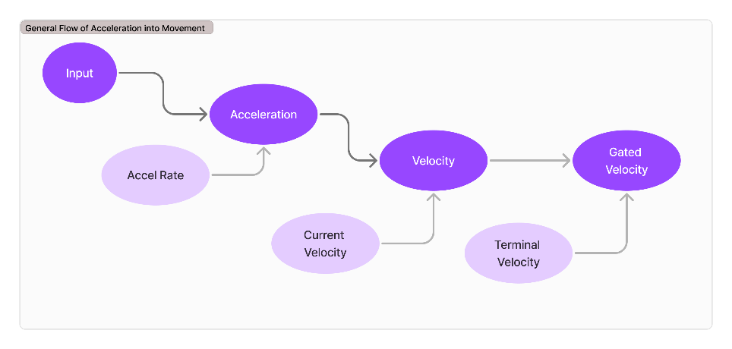
Phase 3 – Kinematic Physics Implementation
Goal: Add basic acceleration-based motion.
Deliverables:
- Kinematic System:
  - Acceleration adds to velocity.
  - Velocity updates position and rotation each tick.
- Debug Verification:
  - Display acceleration, velocity, and position values.
- No mass or drag yet—just clean, predictable motion.
Reflection Prompt:
- Compare Phase 2 movement vs Phase 3 movement. What differences do you observe? Is the motion smoother?
(Tip: Compare this to your Phase 2 behavior to observe smoother and more natural transitions.)

- Estimated time: 3–4 hours.

Assessment Focus:
- Player pawn moves and rotates accurately in response to input.
- Debug tools (arrows, vectors, PrintString) correctly visualize direction, velocity, and input.
- Input responsiveness: all actions perform consistently without unexpected behavior.
- Code readability and logical organization of movement logic.
- Demonstrated testing and iteration to ensure reliable input handling.

Phase 4 – Dynamic Physics Implementation
Goal: Evolve your movement system from kinematic to dynamic by introducing real physical properties that influence motion.
Concept Overview:
Dynamic physics means the player’s motion now reacts to forces in a more realistic way. Instead of directly controlling velocity, you’ll apply forces and let Unreal’s physics system (or your own custom equations) handle acceleration and velocity changes based on mass, drag, and possibly friction or momentum.
Deliverables:
- Physics Properties Added:
  - Mass: Affects how much force is needed to accelerate the pawn.
  - Linear and Angular Drag (Damping): Slows motion over time.
- Force-Based Movement:
  - Inputs now apply forces or impulses instead of setting acceleration directly.
  - Player rotation and movement should respond dynamically to these forces.
  - Force = Mass * Acceleration → apply to pawn using AddForce
- Debug and Analysis Tools:
  - On-screen visualization of applied forces and resulting velocity.
  - Optional graphing or trace lines for force direction and drag effects.
- Comparison Test:
  - Demonstrate and record differences between your Phase 3 (Kinematic) and Phase 4 (Dynamic) movement.
- Estimated time – 3-4 Hours
Assessment Focus:
- Correct application of physics concepts (mass, drag, and forces).
- Stable and predictable simulation (no jitter or infinite acceleration).
- Evidence of testing and iteration to balance realism with control.
(Tip: Use Unreal’s Physics Debug visualization and the “Show Collision” command to help tune your system.)

Bonus Modules – Choose at least ONE of Bonus Module A or B to complete for full marks.

Optional Bonus Module A – Input Refinement (Using PlayerController Properly)
Goal: Improve your project’s input structure by ensuring input is handled through the PlayerController, not directly in the Pawn. This creates a more modular and scalable architecture.
Concept Overview:
In Unreal, the PlayerController is responsible for interpreting player input, while the Pawn handles physical response. Separating these ensures clean input flow and makes your project easier to expand (for AI or networked players later).
Deliverables:
- Move input bindings and logic (e.g., MoveForward, Turn) into the PlayerController.
- Use the Pawn Interface or direct references to pass movement/rotation values.
- Debug printouts to verify the PlayerController sends clean, normalized data.
- Optional: Add customizable input mappings for different control schemes.
- Estimated time – 3-4 Hours

Assessment Focus:
- Proper architectural separation of input logic.
- Clean and readable communication between PlayerController and Pawn.
- Input system remains fully functional and debuggable.

Optional Bonus Module B – Camera Systems (Smoothing and Easing)
Goal: Enhance player feedback and polish by implementing smooth, responsive camera behavior.
Concept Overview:
A well-designed camera improves game feel by reacting naturally to movement. This module adds easing, lag, or spring arm smoothing to create a more cinematic experience.
Deliverables:
- Use a Spring Arm with camera lag and rotation lag enabled.
- Experiment with interpolation or lerp functions to smooth transitions.
- Optional: Add camera shake or offset for acceleration/deceleration.
- Document your chosen parameters and reasoning (e.g., why your lag settings feel best).
- Estimated time – 3-4 Hours
Assessment Focus:
- Correct use of interpolation/easing functions (RInterpTo, FInterpTo, etc.).
- Smooth, non-jittery camera motion that enhances gameplay.
- Balance between responsiveness and cinematic motion.

Deliverable assets will be:
- Design Document - PDF File (can be a figma export).
- Unreal Project - Zip file
- Exported playable build - Zip file.
Please hand in your UE Project in a zip file with the naming AM3_A3_FirstInitialLastInitial.zip and the build with AM3_A3_Build_ FirstInitialLastInitial.zip
E.g. AM3_A3_DF.zip and AM3_A3_Build_DF.zip

Record a short video (3-5 min) OR provide a 1-2 page written (with images) outline highlighting what you did for each phase.
- Short Video or written summary - Some easily accessible video format such as .MOV or MP4 (no exotic codecs) or PDF.

Assignment 3: 3D Pawn – Part 1 Rubric
Category | Exceeds Expectations (Full Marks) | Meets Expectations | Below Expectations | Points
Phase 1 – Concept & Setup | Design document is thorough, input mapping is clear, blueprints correctly created, placeholders functional, planning supports later phases. | Design document is complete, most blueprints created, placeholders present. | Design document incomplete, missing blueprints, placeholders missing or unclear. | 15
Phase 2 – Core Movement Prototype | Player moves and rotates accurately; debug tools show input, direction, and velocity clearly; all actions respond consistently. | Player moves and rotates with minor inconsistencies; debug tools present but partially incomplete. | Player movement inconsistent; debug tools missing or non-functional. | 20
Phase 3 – Kinematic Physics | Acceleration and velocity correctly update position and rotation; motion is smooth; debug output accurate; code well-organized and readable. | Motion works with minor inaccuracies; debug partially functional; code mostly readable. | Motion buggy or inconsistent; debug not informative; code hard to follow. | 20
Phase 4 – Dynamic Physics | Mass, drag, and forces applied correctly; motion is stable and realistic; debug visualization shows forces/velocity; comparison to Phase 3 documented. | Dynamic physics applied with minor issues; motion mostly stable; some debug output. | Physics poorly applied; motion unstable; no debug or comparison. | 20
Bonus Module (A or B) | At least one bonus module implemented fully; input or camera improvements function correctly; additional documentation/reflection included. | Bonus module attempted partially; some features functional. | Bonus module not attempted or non-functional. | 15
Overall Presentation & Reflection | Project well-organized; code readable; reflection prompts completed thoughtfully; testing clearly documented. | Project mostly organized; some reflection/testing documented. | Project disorganized; little or no reflection/testing documented. | 10
Total: 100 Points
Notes:
- Students must complete at least one bonus module to receive full marks.
- Reflection prompts can be included in each phase to support grading.

